**High-Availability Power BI Gateway Clusters on Azure**

Building resilient data pipelines often starts with a solid gateway strategy. One powerful approach is creating an on-premises data gateway cluster in Azure. This ensures high availability and seamless connectivity between on-premises data sources and Power BI (or other Azure services). Here’s a quick rundown:

1. **Install Windows Azure Virtual Machine**

Make sure to install your Azure Virtual machine on Windows 10 or higher, In this scenario I created the Gateways on different Availability Zones to increase resilience

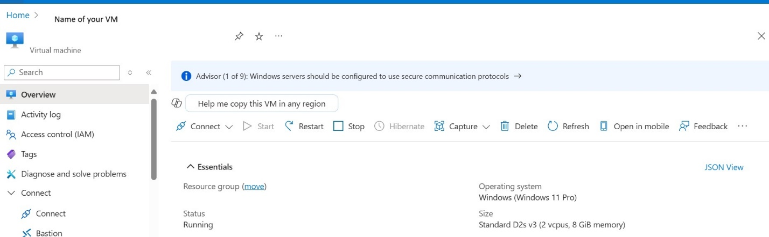

**2. Configure Your Gateway**

Begin by installing the **On-premises data gateway** on an Azure VM or a local server. During setup, you can opt to join an existing gateway cluster or create a new one. Clusters help balance workloads and provide failover if one gateway goes down.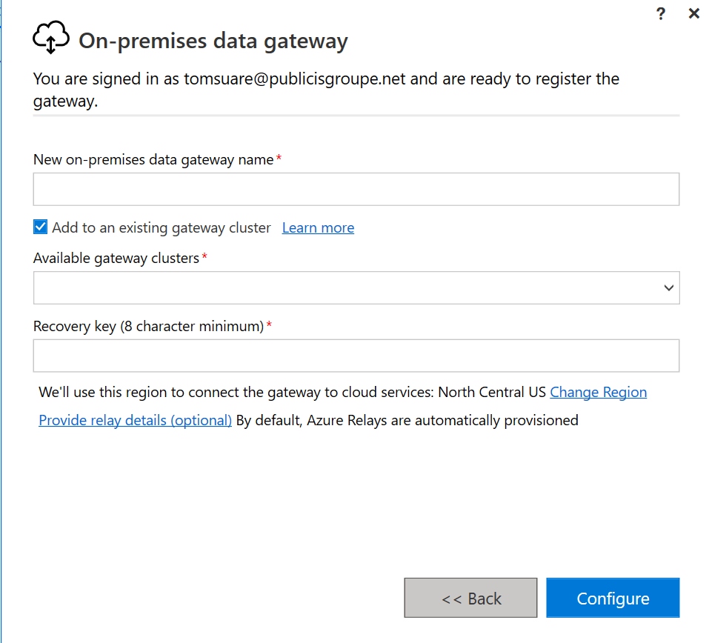

**2. Create or Join a Cluster**

In the Power BI Service, head to **Manage Gateways** and choose **Add to an existing gateway cluster** or **Create a cluster**. Give your cluster a descriptive name (e.g., “testcluster”) and ensure your department, contact info, and other settings are updated.

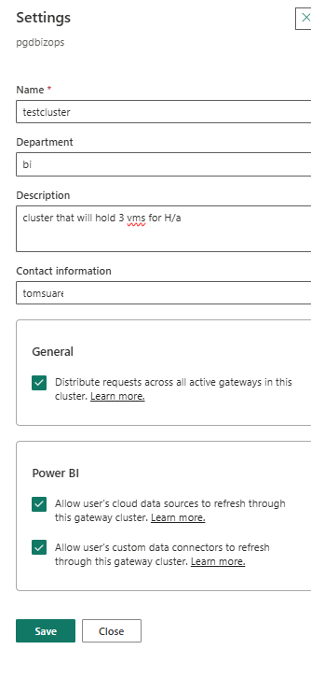  
Make sure to click on distribute requests across all active gateways so this works sort of like an internal load balancer that will distribute your dashboards requests for h/a. Make sure to click also allow user’s cloud data sources to refresh if this is going to be used for refreshing data bases hosted on cloud.

**3. Manage Connections and Data Sources**

Once your gateway cluster is set up, add data sources like SQL Server, PostgreSQL, or others. This step involves mapping your on-premises or hosted data to Power BI datasets.  
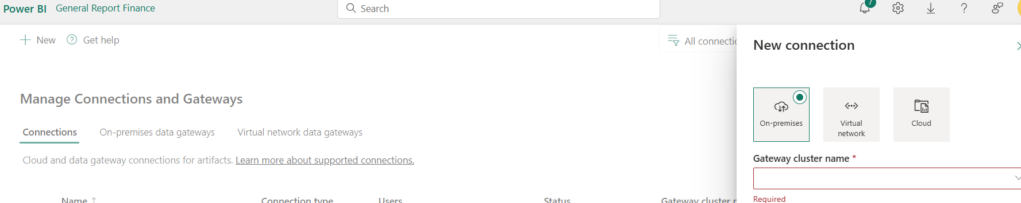

This involves first creating the connections and testing them, and then turning on the gateway connection options and making sure you map each cloud source to its recently created connection.

**4. Verify Your Cluster’s Health in Azure**

If you’ve deployed the gateway on Azure VMs, you can view their status, version, and availability in the Azure portal. This provides a central location to monitor performance and usage. You can turn on and off different gateways and check the status for each VM.

**Pro Tip (for PostgreSQL Users)**

If you’re using PostgreSQL, install **Npgsql version 4.0.10.0 or earlier** to avoid compatibility issues with certain gateway connections.

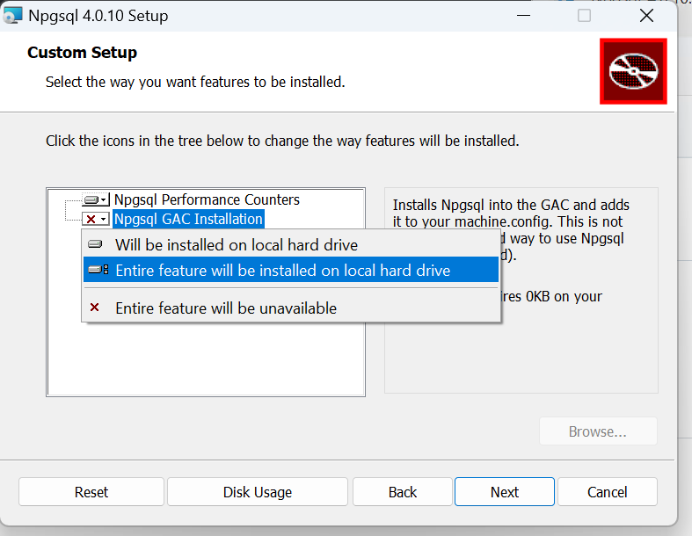

**Why Clusters?**

A gateway cluster means zero single points of failure, load balancing across multiple nodes, and continuous data access. It’s especially valuable for organizations that can’t afford downtime in their analytics and reporting pipelines.